**JAVASCRIPT Basics**

**Function**

* Block of code that fulfil a specific task.
* Syntax:

**function** fun_nam() {…..}

* Advantage:
  + Not bulky
  + Readability increases
  + Not so much buggy
  + Not reusing the same task
* It can also take parameter which known as function parameter.
* Hoisting is also being used in this and it is automatic.

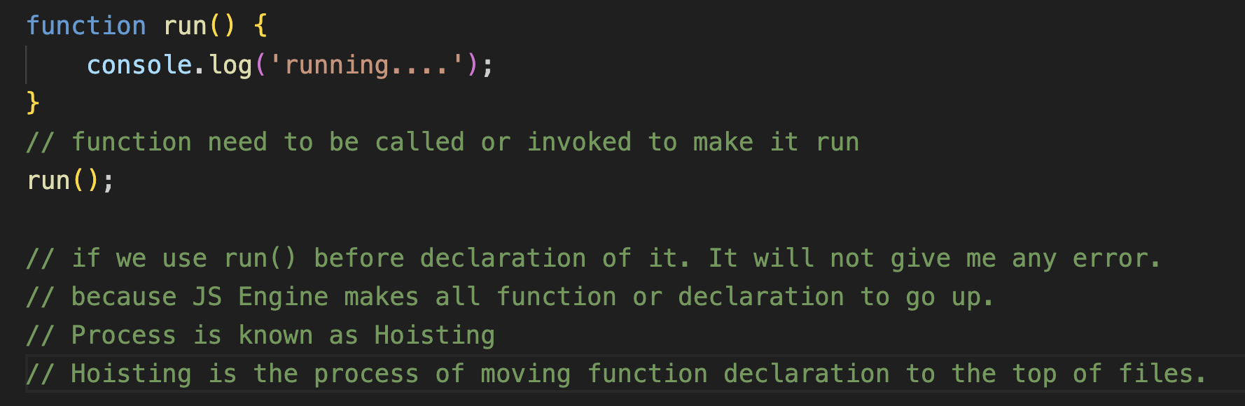

* Function assignment:
  + Here hoisting is not used

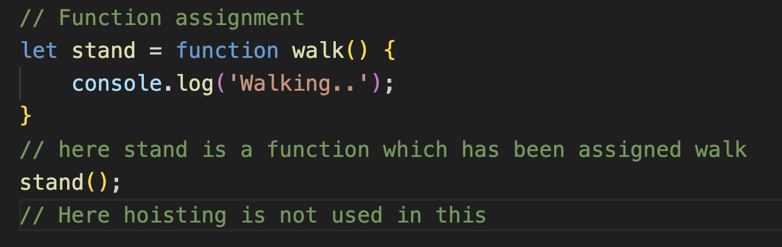

* + Named and anonymous function assignment.
* Can dynamic typing can also be used in function?

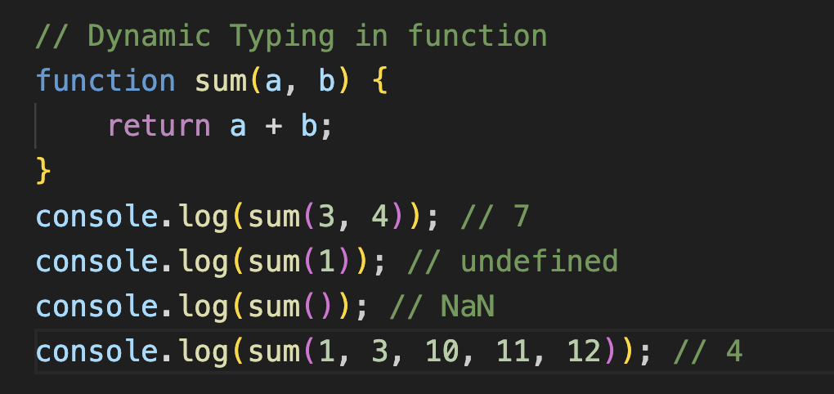

* + These extra numbers are stored in arguments objects.
  + And these are stored in key value pairs means objects.
* Rest Operator (…)
  + Function can have many parameters. we can manage these parameters using rest operator.
  + Like (…args)

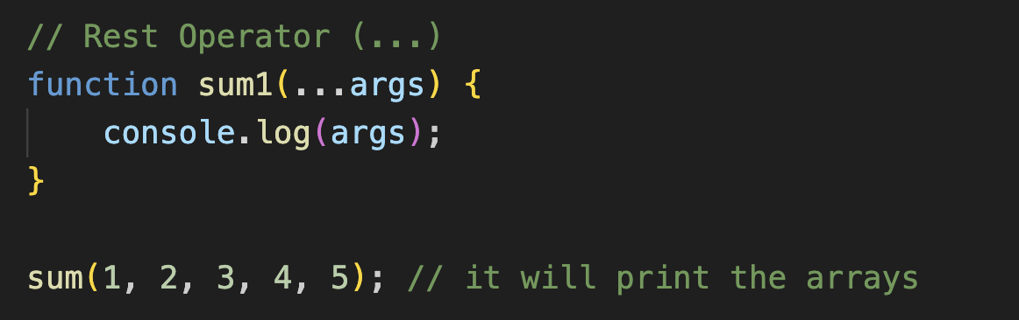

* Default Parameter
  + If we do not have any parameter explicitly mentioned then there, we can use default parameter.
  + Start giving default parameter from right to left.

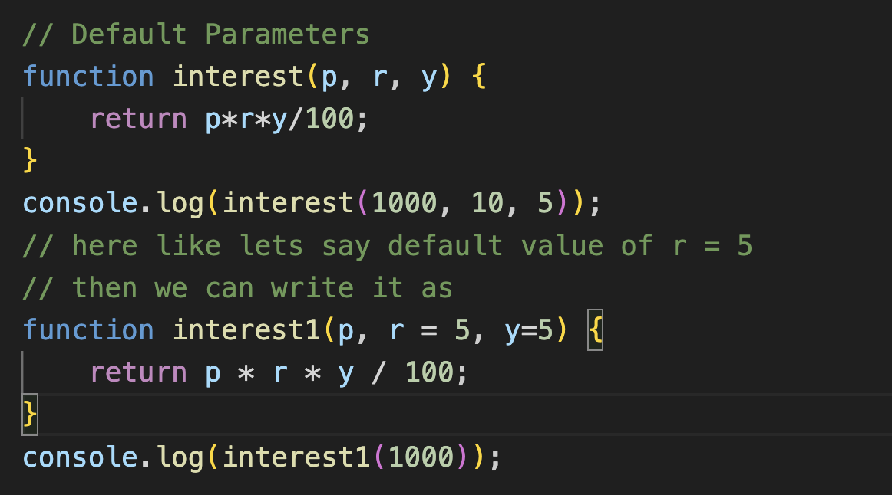

* + But we can use undefined values. But it is bad practice.
* Getter / Setter
  + These are used when we want to use some kind of again and again.
  + Getter: to get the value
    - Getter function is created using get keyword inside the object.
  + Setter: to change or mutate properties
    - Setter function is created using set keyword inside the object and this function required some kind of parameter.
  + 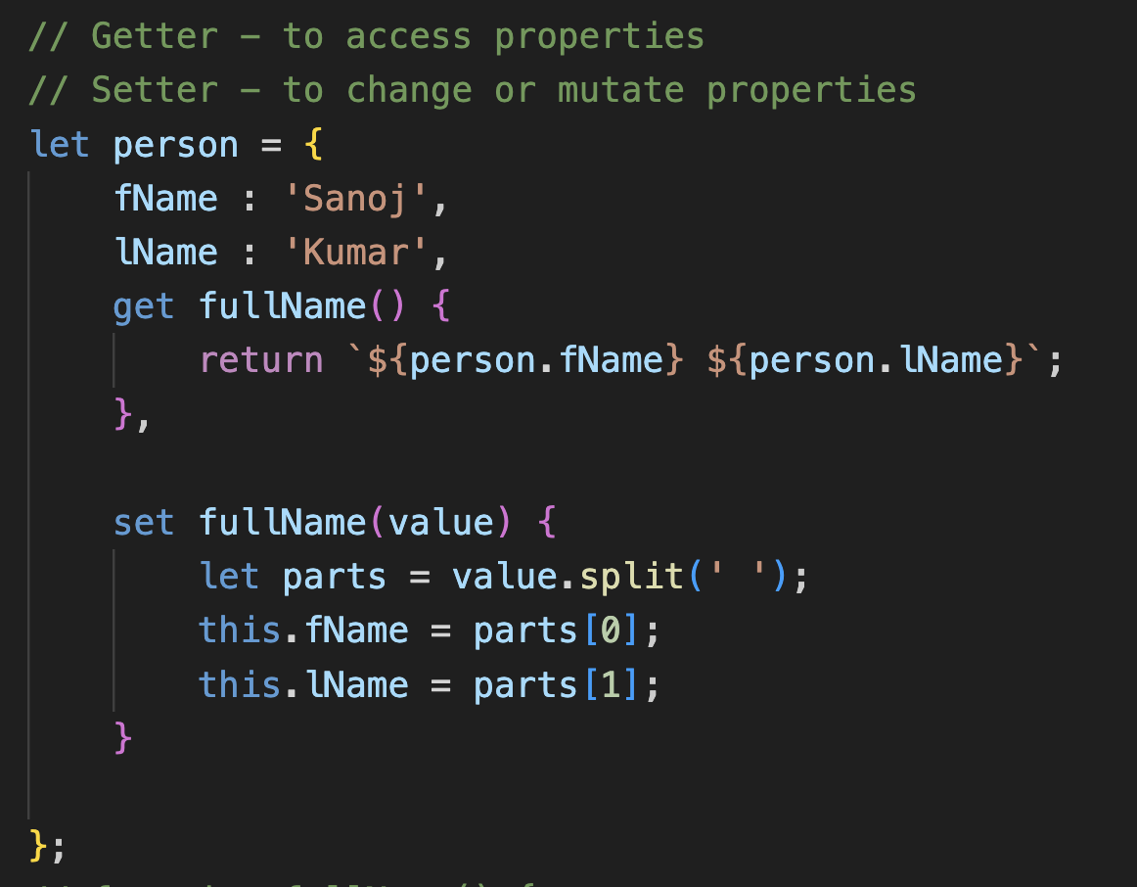

**Error Handling:**

* To handle error in JS Code.
* These errors are handle using try and catch block.
* Let say if we are sending number instead of sending full name then it will throw error.

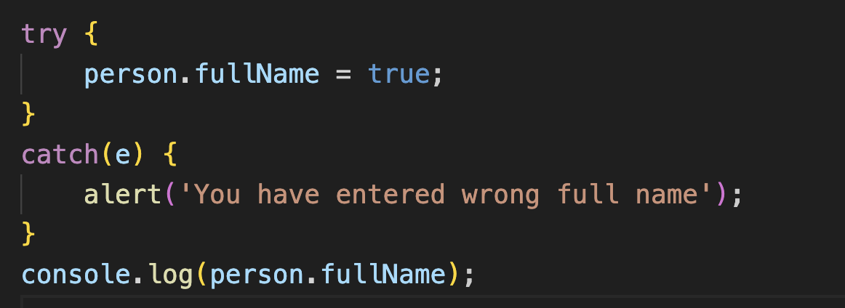

* + Flow of code will be when any function will be called it will continuously run till no error will be found, if any error occurs and we have written the code like throw this error. Then the remaining code will not be executed in the function after the error and try block now having the error then this will be handled by the catch block.
  + First function -> try -> catch.

**Scope**

* Like we have learned about the let variables in JS. These are the variables which are only scoped in the closed brackets.
* Let keyword are basically scoped to its nearest curly brackets whereas var keywords are scoped inside the function in which it is defined/declared. If var variable is not declared / defined in any kind of function then it is scoped in whole js code.
* 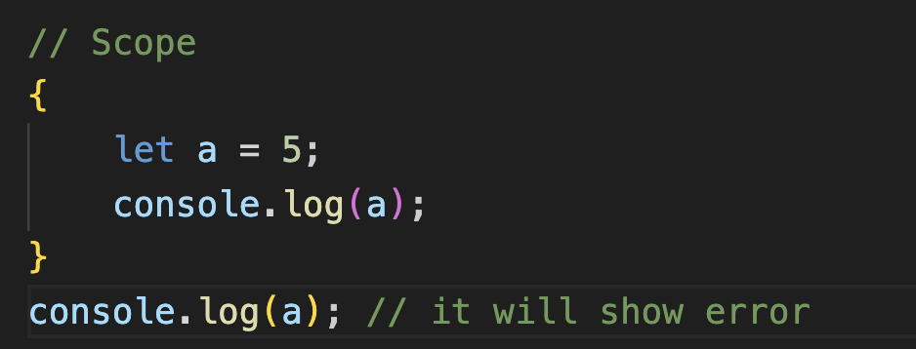
* 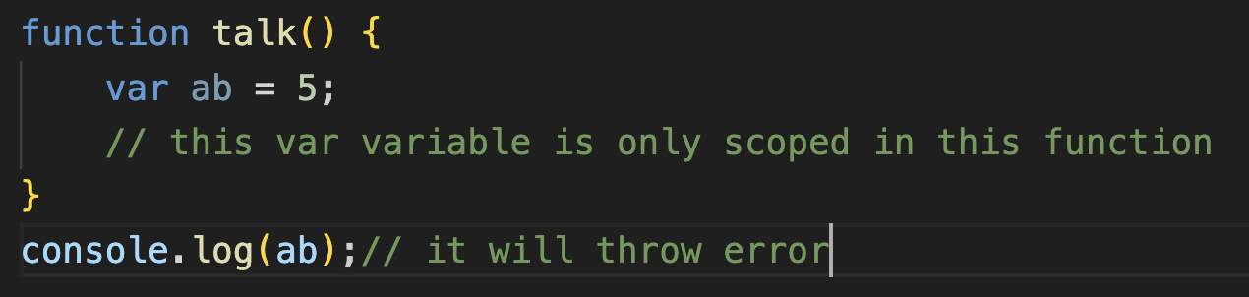
* 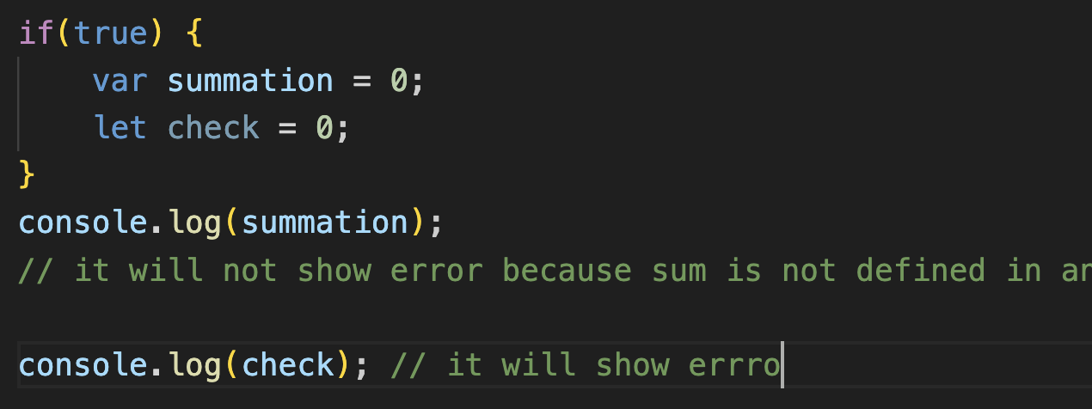
* If we are using variable name again in function and in global scope then it will not show error.
* If we are creating a loop with var keyword these can be accessed outside the loop but not with let keyword variable.